## UI

### Header



## DB scheme

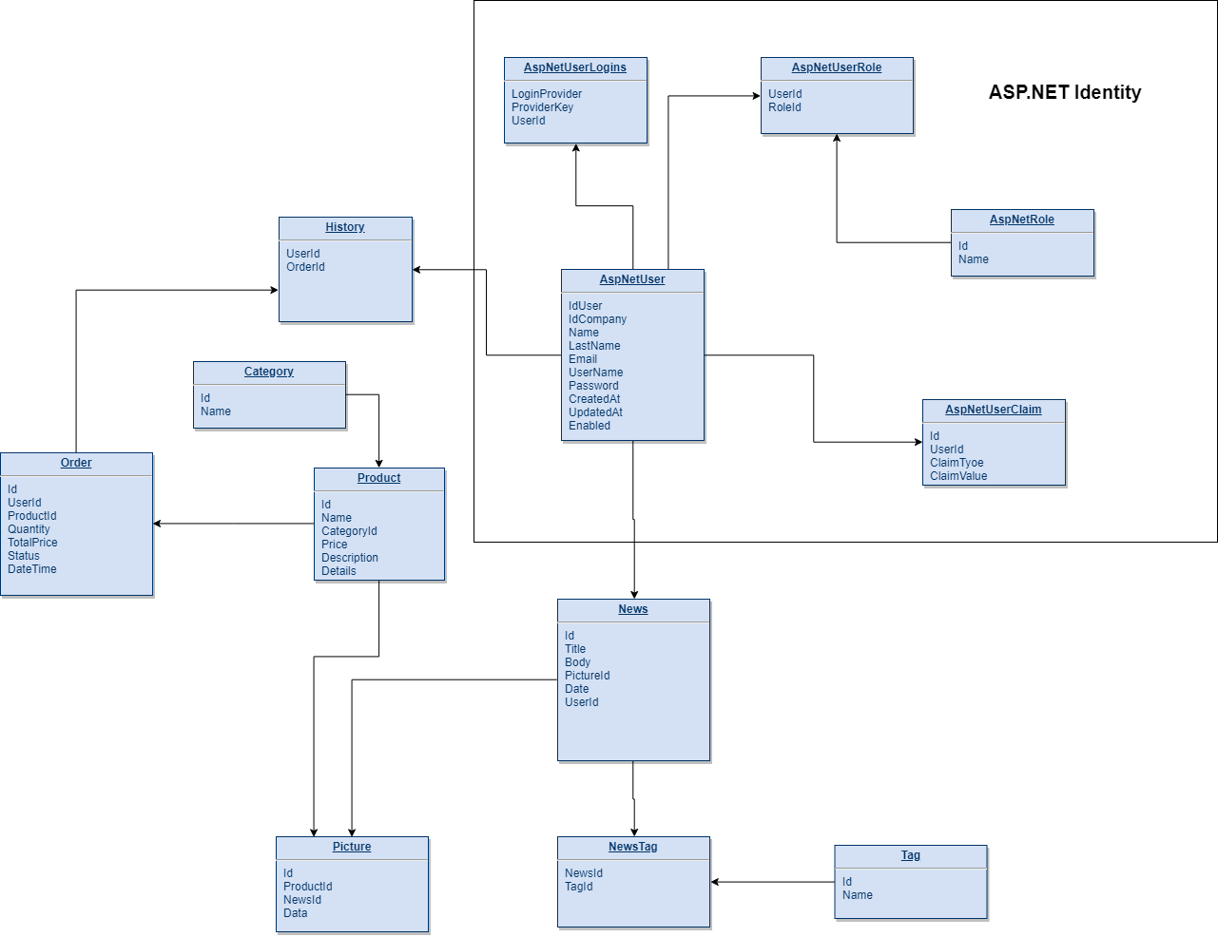

## Application modules description (Logger, DB Access Layer, controllers, views, models, managers and so on);

WebStore App back end modules:

1. Controllers
   1. Category controller
   2. ProductController – CRUD operations with products
   3. OrderController – CRUD operations with orders
   4. NewsController – CRUD operations with news
   5. HistoryController – CRUD operations with history
   6. AccountController -
2. Logger – Nlog
3. DB Access Layer – will be implemented with Entity Framework
4. Services
   1. ProductService – CRUD operations with products
   2. OrderService – CRUD operations with orders
   3. NewsService – CRUD operations with news
   4. HistoryService – CRUD operations with history

## Architecture scheme;

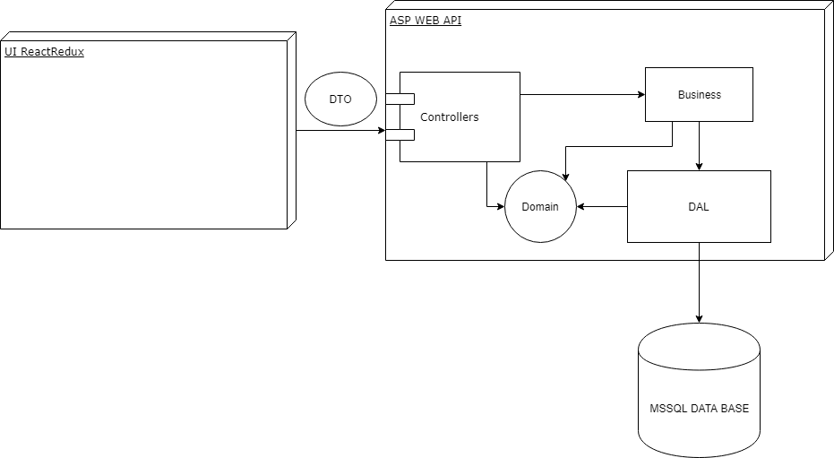

## Error handling;

https://docs.microsoft.com/en-us/aspnet/web-api/overview/error-handling/web-api-global-error-handling